Zimmerman Note: Use the Primary source analysis tool worksheet to complete this activity
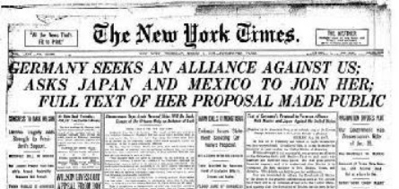

From the New York Times on March 1st, 1917
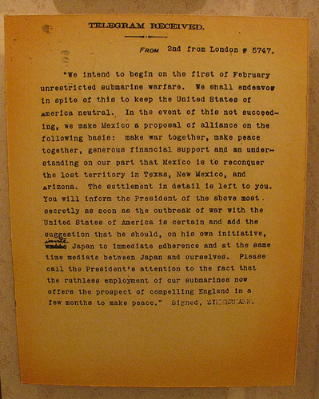
The Zimmerman Note was a telegram from German Foreign Minister Arthur Zimmermann to the German Minister to Mexico, von Eckhardt, offering United States territory to Mexico in return for joining the German cause. This message helped draw the United States into the war

