Name: Date: Block:

WWI INTERACTIVE MAP: Complete the Map using the 12 steps on the back side of this paper
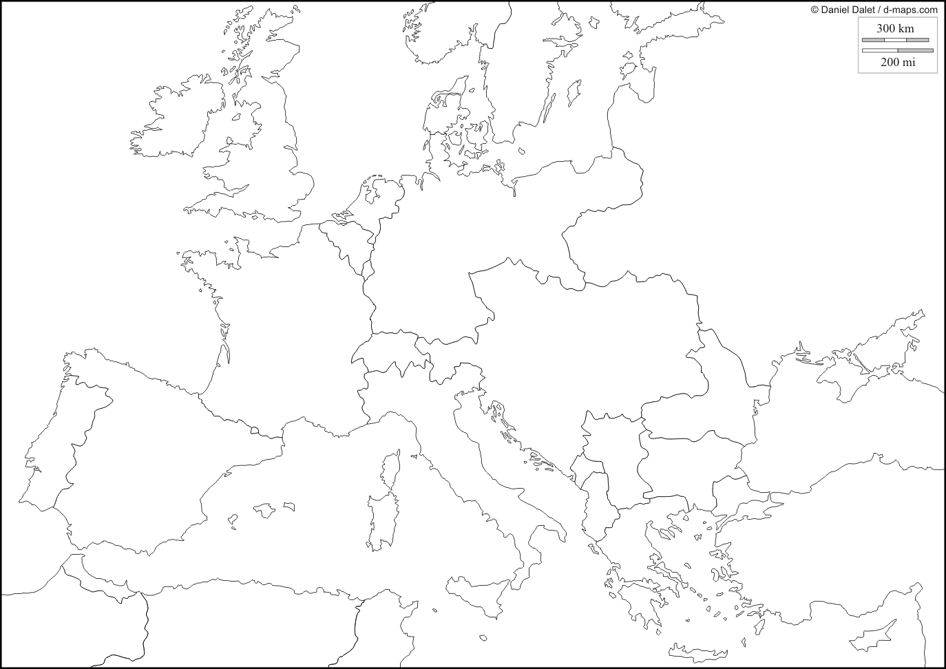

- Draw a gun in Bosnia, the location where Gavrilo Princip assassinated Franz Ferdinand (the spark to World War One).

- Label & shade the Central Powers in WWI: Germany, Austria-Hungary, Ottoman Empire, Bulgaria

- Label and shade (with a different color) the Entente Powers in WWI: France, Russia, United Kingdom, Belgium, Serbia, Portugal, Greece, Albania, Montenegro

- Add to the Entente Powers: Italy and Romania, who agreed to join the allies in exchange for land spoils after the war.

- Label the “Western Front” on the map with a thick dashed line, (include stick figure soldiers on either side).

- Label the Eastern Front on the map (include stick figure soldiers on either side).

- Label and place German “U-Boats” in the North Sea and around the United Kingdom (using small, shaded ovals).

- Place a star on the 1916 Battle of the Somme (the largest battle of World War One).

- Cross out Russia, and write “1917 Communist Revolution” next to it, indicating that Russia had dropped out of the war.

- The United States enters the war on the side of the allies

- Central Powers Surrender in 1918 (X out the Central Powers)

- Allies Win! (put check marks on the remaining allies)

