Label the following political areas on the world map on the front of this worksheet:
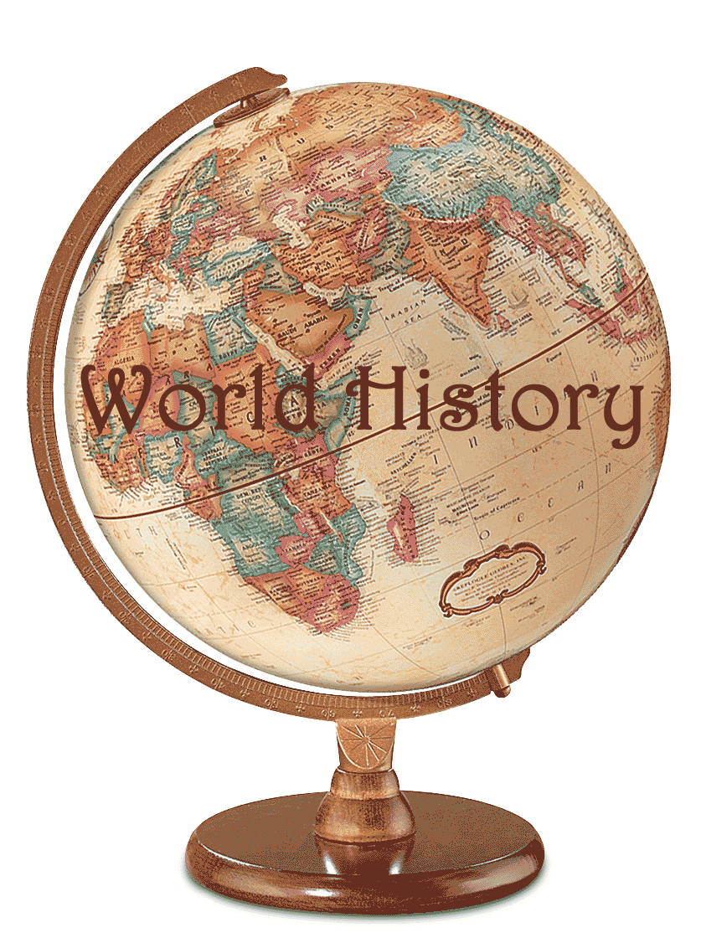
- Label: North, South, East, and West on your map

- Label: ALL 7 Continents.

- Label: all three countries in North America (color each a different color

- Label: Brazil, Argentina, and Peru in South America (color each a different color)

- Label: Washington D.C., Los Angeles CA, Chicago IL, and New York, NY

- Label: Spain, Italy, and France in Europe (color each a different color)

- Label: Iraq, Syria, Iran, India, China, and Russia in Asia (color each a different color)

- Label: Somalia, and Egypt in Africa (color each a different color)

** For five points extra credit** Label the capitals of each country you just labeled and colored.
Once you have finished labeling all of the areas above, answer the following questions:

- How many countries are in North America? ________________________________

- What is the largest Country in South America? __________________________________

- What African country is an island? _______________________________________

- If I was traveling from Portugal to Poland what countries would I pass through?

_______________________________________________________________________________________

- If I traveled from Algeria to Sudan, What countries would I pass through?

___________________________________________________________________________________

- What is the largest country on the Arabian Peninsula?

____________________________________________________________________________________

- What is the capitol of China? _____________________________________

