Label the following physical features on the world map on the front of this worksheet:
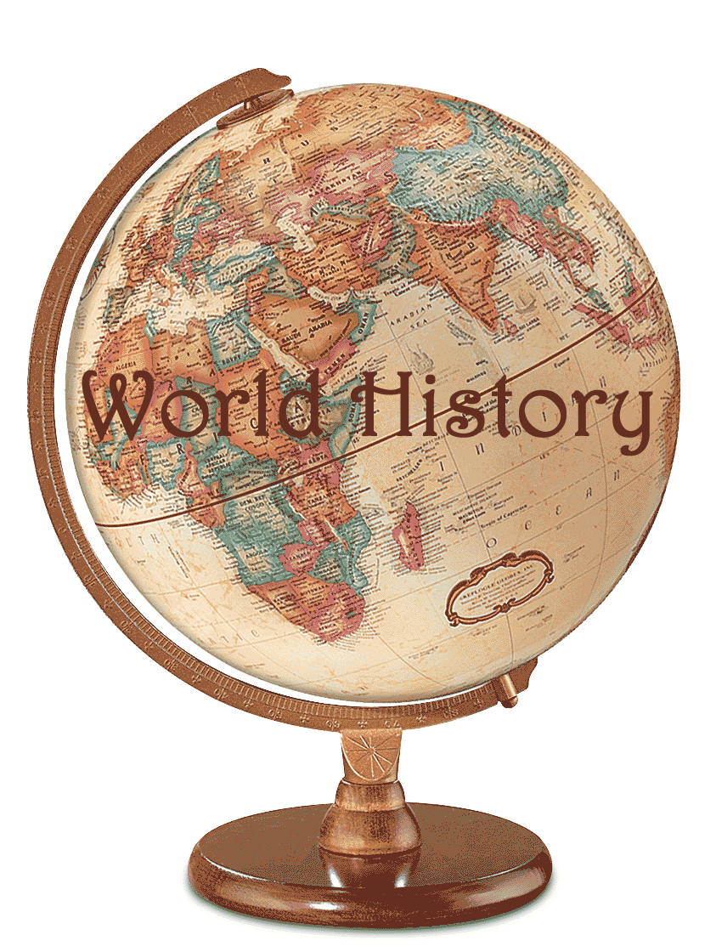
- Label North, South, East, and West on your map

- Label ALL 7 Continents. (color each continent a different color)

- Label ALL 5 oceans: (color each ocean blue)

- Label the following bodies of water: Mississippi River, Amazon River, Nile River, Gulf of Mexico, Mediterranean Sea, Sea of Japan, Coral Sea (color each blue)

- Label the following Mountain ranges: Rocky Mountains, Ural Mountains, Andes Mountains, Mt. Kilimanjaro (Color mountains brown)

- Label the following deserts: Sahara Desert, Gobi Desert. (color each red)

- Draw a line and label the Equator

Once you have finished labeling all of the areas above, answer the following questions:

- What ocean borders North America to the East? ________________________________

- The Amazon River is on what continent? __________________________________

- What continent is an Island? _______________________________________

- The Equator runs in what directions? _________________________________

- The Sahara Desert is located on what Continent? ____________________________

- What continent are the Ural Mountains located? ____________________________

- The Coral Sea is closest to what Ocean? _____________________________________

