The Lost Colony

Before Jamestown and Plymouth, the English attempted to forge a colony at Roanoke. Within three years, it had disappeared, leaving a mysterious clue behind. What really happened to the Roanoke settlers? The Roanoke colonies, the result of three attempts at colonization on the eastern shores of what would become North Carolina, laid the foundation for later English colonization initiatives.
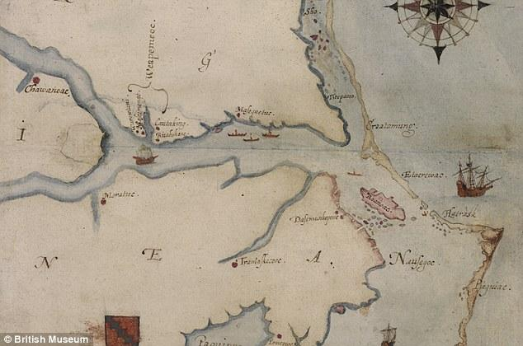
In April of 1584, explorers Phillip Amadas and Arthur Barlowe set out from England to survey the coast near Cape Hatteras. In the course of their expedition, they encountered few obstacles and their positive report prompted Sir Walter Raleigh , with permission from Queen Elizabeth I, to establish a colony in the New World. In 1585, Sir Richard Grenville, Raleigh’s cousin, sent seven ships loaded with colonists and provisions to establish a colony on Roanoke Island. Although the settlement survived, poor relations with the natives and food shortages constantly plagued the colony. After English supply ships failed to reach Roanoke Island, the colonists returned to England, and in the process missed the arrival of a re-supply ship. The ship’s crew found the colony deserted and left fifteen men at the site to await their return. They never did, and eventually the men returned to England.
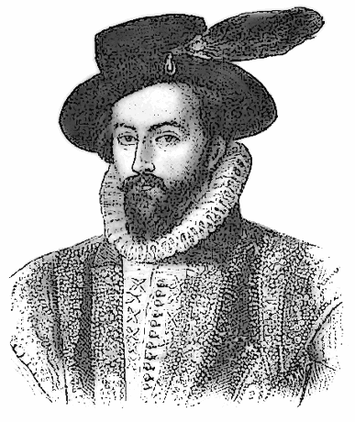
Two years later, Grenville sent another colonial expedition of 150 men, led by artist John White. The third colony, choosing the same location their predecessors had abandoned, saw improved relations with natives and the 1587 birth of Virginia Dare, the first child born to English parents in the New World. Soon after Dare’s birth, White returned to London to secure more provisions for his fledgling colony. Due to a war between the English and Spanish he was not allowed to return to Roanoke for three years. When he did return he found the colony abandoned with no trace of settlers and most structures destroyed. The only clue discovered was the word “Croatoan” carved in a tree. Exhaustive searches were conducted but to no avail. No one knows what happened to them. It’s possible that the colonists joined with the friendly Croatoan natives. Were they massacred by the unfriendly Wanchese tribe? Did a bad hurricane wipe everything and everyone out? No one knows for sure.
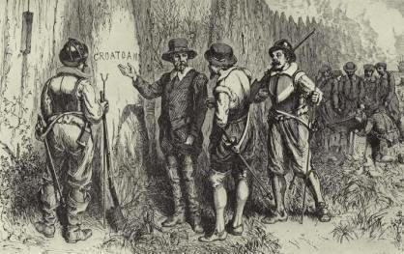

Close Reading

Read the article “The Lost Colony” and complete the activities below.

1. Chunk the article into sections. Draw a line between each paragraph and number them.

2. Draw a box around important vocabulary for this article. Think of important people, places, and names while you are searching for vocab.

Complete the chart below.
Paragraph # | Main Idea | 2 details from paragraph supporting the main idea
1.

2.

1.

2.

1.

2.

What do you think might have happened to the colonists “lost” at Roanoke?

