Name Date
Reconstruction Era Project
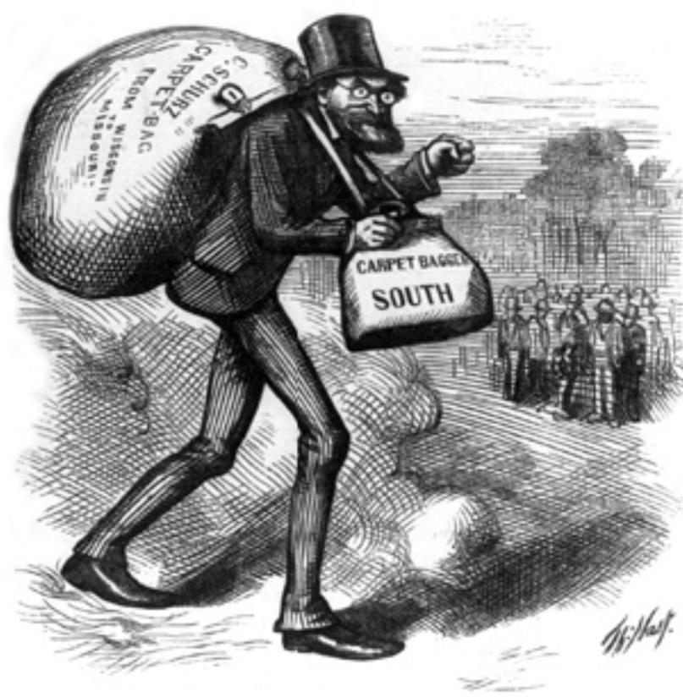
Reconstruction was the time period during which the United States began to rebuild after the Civil War, lasting from 1865 to 1877. The term also refers to the process the federal government used to readmit the Confederate States. Complicating the issue was the fact that Abraham Lincoln, Andrew Johnson and Congress had differing ideas on how Reconstruction should be handled.
From 1863 to 1869, Presidents Abraham Lincoln, and Andrew Johnson (who became president on April 15, 1865) took a moderate position designed to bring the South back to normal as soon as possible, while the Radical Republicans (as they called themselves) used Congress to block the moderate approach, impose harsh terms, and upgrade the rights of the Freedmen (former slaves).
In order to further understand this time period in our history you will work in groups to research and create a project that represents important factors associated with Reconstruction.
Directions: In groups of no more than 4
Step 1: You need to select one of four perspectives of the Reconstruction era and create a project that accurately depicts that viewpoint, 1 per group:

- Southerner (Confederate) *Former slave
- Northerner (Union) *Carpetbagger
- Scalawag

Step 2: Research. Your project needs to show your understanding of the following items as it affects the life of your chosen viewpoint
- Differing Political Goals of Reconstruction & its opposition
- Black Codes & Freedmen
- 13th, 14th, & 15th Amendments
- Economics of your part of the country after the war
- Explain the achievements and failures associated with Reconstruction

Step 3: Be creative! Some project ideas:
- Create a tri-board poster ^Create a museum exhibit *Create a website
- Make a board or card game * newspaper *interview
- Write journal entries from the perspective of the people involved
- Create a documentary using movie maker

Due Date January 22nd :BEGINNING OF CLASS! Rubric:
Accomplished Proficient Developing
Daily Check-In | 10 pnts x3=30
- Differing Political Goals of Reconstruction & its opposition | 10 points
- Black Codes & Freedmen | 10 points
- 13th, 14th, & 15th Amendments | 10 points
- Economics of your part of the country after the war | 10 points
- Explain the achievements and failures associated with Reconstruction | 10 points
- Cited Sources | 10 points
- Creativity/Neatness | 10 points
Total Score | 100 points | 100 | 80 | 0

