Nat Turner Rebellion: A Mini DBQ
Question: Was Nat Turner a hero or villain?

Directions
- Read the Historical Background surrounding the Nat Turner Rebellion.
- There are five primary sources included. Read each source and answer the accompanying questions.
- Write a well-developed paragraph answering the question.

Historical Background
In August of 1831, seven enslaved men turned the South and the nation upside down when they engaged in a violent and historic bid to gain their freedom. Beginning before dawn on a Monday morning, a band of slaves led by Nat Turner made their way across Southampton County in southeastern Virginia. As they traveled from farm to farm, they killed every white person they encountered and picked up recruits from among the slave population. Within twenty-four hours, fifty-five white men, women, and children lay dead.

By Monday afternoon, whites launched a successful attack against the rebels, capturing or killing most of them that same day. Nat Turner remained at large, and rumors spread that the rebellion had been part of a much more widespread conspiracy of slaves in Virginia and North Carolina. Over the next four months, dozens of slaves were put on trial, and more than twenty were executed, including Turner, who was captured after hiding in the area under a pile of wood for more than two months.

Nat Turner Timeline: 1831
August 22--The rebellion begins with Nat Turner and his group of men.

August 23--Nat's army dissembles after killing 55 white men, women, and children. Nat disappears. An army is set out to bring him in.

October 30--Nat is captured after being on the run for 70 days.

November 1-4--Thomas Gray visits Nat and compiles The Confessions of Nat Turner

November 5--At his trial, Nat pleads his innocence but is found guilty as an insurgent and is sentenced to be hanged.

November 11--Nat is hanged at noon.

Document A
The Confessions of Nat Turner: The Leader of the Late Insurrections in Southampton, Va. As Fully and Voluntarily Made to Thomas R. Gray

[To the Public]
Thomas R. Gray: Public curiosity has tried to understand Nat Turner’s motives behind his diabolical actions. Everything connected with the rebellion was wrapped in mystery, until Nat Turner the leader of the violent and savage band, was captured. I was determined to end public curiosity and write down Nat Turner’s statements, and publish them, with little or no change, from his own words.

Nathaniel Turner:
As I child, I knew I surely would be a prophet, as the Lord had showed me visions of things that had happened before my birth. My father and mother said I was intended for some great purpose. I was a child of uncommon intelligence and I knew I was never meant to be a slave. To a mind like mine, restless, curious and observant of everything that was happening, religion became the subject that occupied all of my thoughts.

Thomas R. Gray: Nat Turner is a complete fanatic. The calm way he spoke of his late actions, the expression of his fiend-like face when excited by enthusiasm, still bearing the stains of the blood of helpless innocence about him. I looked on him and my blood curdled in my veins.

Source: These confessions were narrated to lawyer Thomas R. Gray in prison where Nat Turner was held after his capture on October 30, 1831. His confessions were published on November 5, 1831 for his trial.

1. How does Nat Turner describe himself?

2. How does Thomas Gray describe Turner?

3. How do Turner and Gray’s descriptions differ?

4. Is this a trustworthy source? Explain.

Document B

Turner’s Confession
“Since the beginning of 1830, I have been living with Mr. Joseph Travis. He was a kind master, and
placed the greatest confidence in me. In fact, I had no cause to complain of his treatment of me.
On the 20th of August, it was agreed between the slaves Henry, Hark, and myself to prepare a dinner for the men we expected the next day. There we were to prepare the plan for our uprising, for we had not yet settled on one… It was quickly agreed we should start at home (Mr. Travis’s) on that night. We would spare neither age nor sex until we gathered sufficient force and had armed and equipped ourselves. We stayed at the feast, until about two hours in the night. Then we went to the house. Realizing the alarm might wake the neighborhood, we decided to enter the house secretly and murder the family while they lay asleep. Hark got a ladder and set it against the chimney. I climbed up and lifted a window, entered and came down stairs. I unbarred the door and removed the guns from their places. It was then decided that I must be the first to spill blood. Armed with a hatchet and accompanied by Will, I entered my master’s chamber. It being dark, I could not give a death blow. The hatchet glanced from his head, he sprang from the bed and called his wife. It was his last word. Will laid him dead with one blow of his axe. Mrs. Travis shared the same fate, as she lay in bed. The murder of this family, five in number, was the work of a moment for not one of them awoke. There was a little infant sleeping in a cradle that was forgotten. After we left the house and gone some distance, Henry and Will returned and killed it. Then I marched the slaves over to the Francis’ house about 600 yards away. Sam and Will went to the door and knocked. Mr. Francis asked who was there. Sam replied it was him and that he had a letter. When he came to the door my men seized him and killed him with repeated blows to the head.”

Source: These confessions were narrated to lawyer Thomas R. Gray in prison where Nat Turner was held after his capture on October 30, 1831. His confessions were published on November 5, 1831 for his trial.

- Who does Turner and his men target in their uprising?

- How would you describe Turner based on this part of his confession?

- How do you imagine slave owners responded after reading this?

Document C

“I am led to believe, from all that I can learn, that Nat Turner has been planning his mischief and disruption for quite some time. After pretending to be inspired to rebel by God, he made his announcement of rebellion to the Blacks. He has used every means in his power, to gain control over the minds of the slaves. A dreamer of dreams and a would-be Prophet, he used all the arts familiar to such pretenders, to trick, confuse and overwhelm the slave’s minds.”

Source: Editor. "The Southampton Tragedy." The Richmond Enquirer. Virginia, 27 September 1831.

1. Who do you think is the target audience? How do you know?

2. According to the author of this article, what kind of person is Nat Turner?

3. Is this a trustworthy source? Explain.

Document D

“You had far better all die—die immediately, than live slaves, and throw your misery upon your children. However much you and all of us may desire it, there is not much hope of freedom without the shedding of blood. If you must bleed, let it all come at once--rather die freemen, than live to be slaves.

The patriotic Nathaniel Turner was driven to desperation by the wrong and injustice of slavery. By force, his name has been recorded on the list of dishonor, but future generations will remember him among the noble and brave.”

Source: Henry Highland Garnet speech, “An Address To The Slaves Of The United States” (1843). Garnet’s speech was delivered at the National Negro Convention of 1843 held in Buffalo, New York. The convention drew 70 delegates including leaders like Frederick Douglass.

1. Who is the author of this document speaking to? How do you know?

2. According to the author of this speech, what kind of person is Nat Turner?

3. Is this interpretation of Turner trustworthy? Why or why not?

Document E

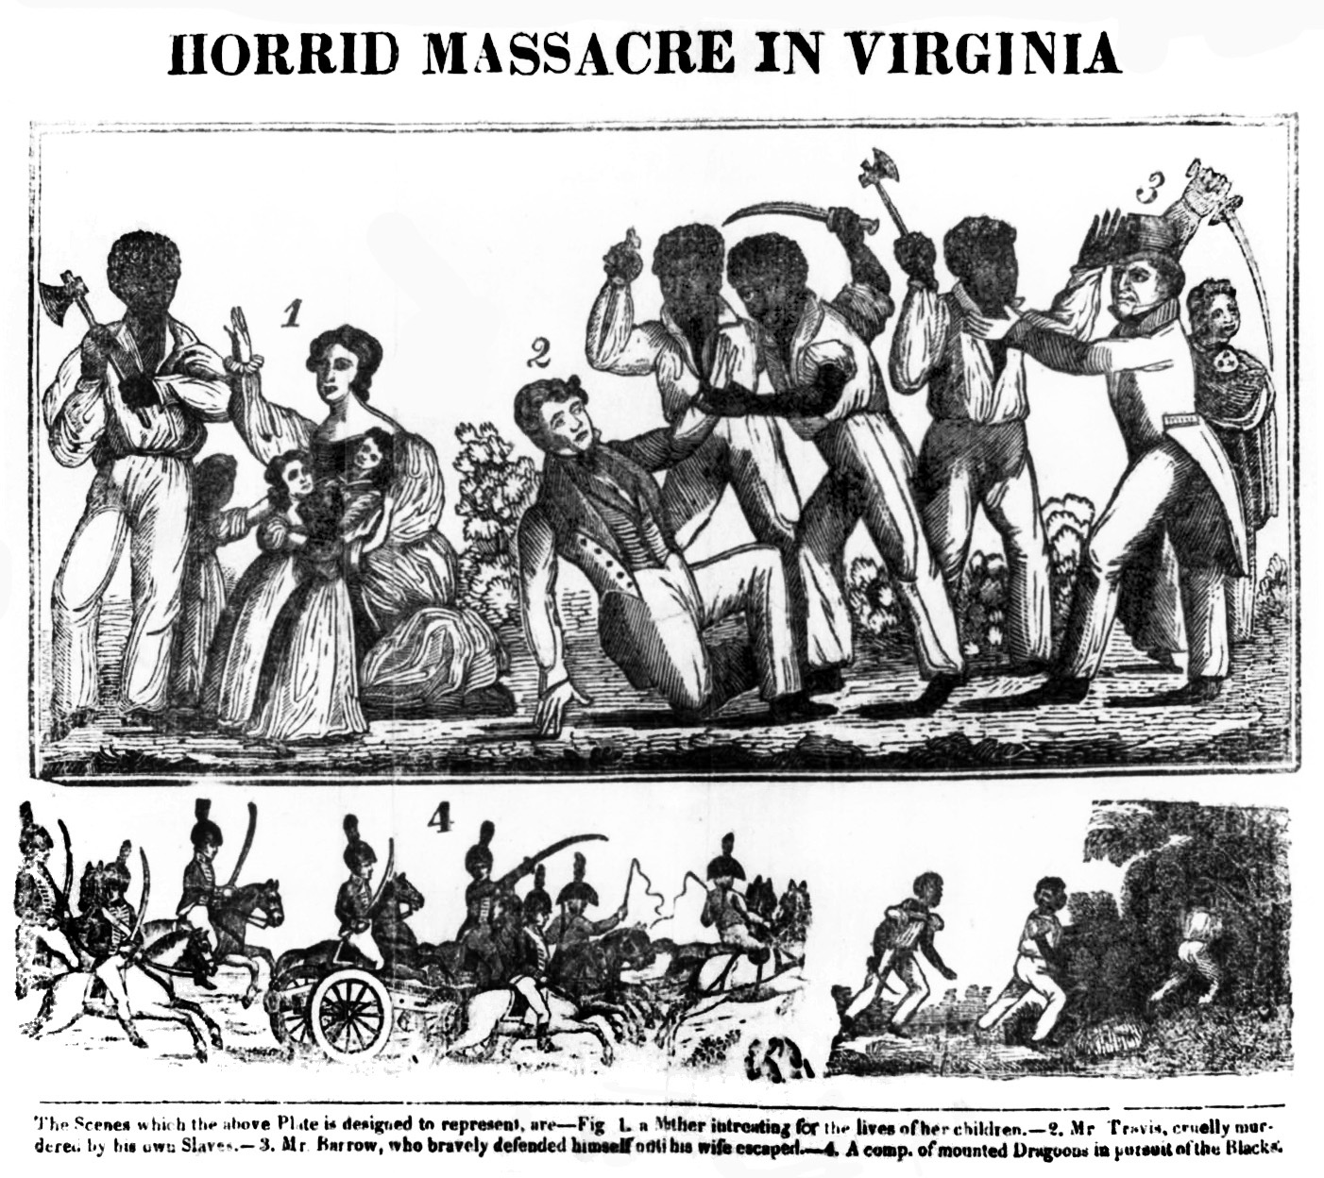

Source: A wood engraving depicts the “Horrid Massacre in Virginia” during Nat Turner’s Rebellion, 1831.

- Who do you think is the intended audience for this image? How do you know?

- According to this document, how is Turner depicted?

- Is this interpretation of Turner trustworthy? Why or why not?

Question: Was Nat Turner a hero or villain?

Now it’s time to answer the question, Was Nat Turner a hero or villain? In the space below, write your answer. Write a well-developed paragraph. Include a topic sentence which answers the question (Nat Turner was a hero or Nat Turner was a villain.). Provide at least three reasons to support your answer. Cite at least three documents within your paragraph as evidence. Use specific quotes when applicable. End your paragraph with a concluding statement. Your paragraph should be written in no less than seven sentences.

