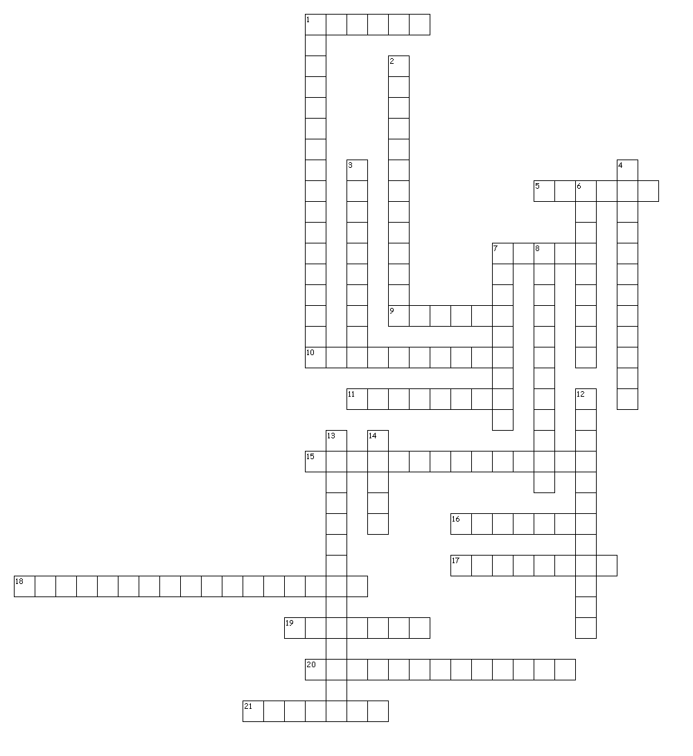
Interim 3 review

Name: Date: Block:

Across
1. This organization became less powerful as a result of the Scientific Revolution
5. The invention of the printing press helped spread this mans ideas.
7. A common doctor would be a member of this estate in France
9. The renaissance impacted society intellectually because former _______ were questioned.
10. This system gave Spanish colonists the power to force natives into slavery
11. He provided stability in France after the revolution
15. Women should be treated equal
16. Last name of the Mexican priest who was killed during the Mexican revolution.
17. This was a major characteristic of the Renaissance.
18. This is a mix of beliefs between the natives and colonizers.
19. In French society, the 3 _______.
20. The Enlightenment ideas instilled a belief in a person's _________
21. The renaissance grew in northern Italy because people were ______.

Down
1. New crops were introduced to Europe as a result of this.
2. The American Revolution was influenced by the ideas of this Era
3. Earth is the center of the universe
4. The idea of gaining new markets to provide wealth to the mother country
6. The reformation and Renaissance encouraged people to question _______.
7. First name of the Haitian leader
8. The scientific revolution would be considered what type of revolution?
12. similar to an absolute Monarchy
13. The willingness of people to hand over their rights for law and order.
14. Gold, God, and ________

