Name: Date: Block:

North Carolina Gold Rush

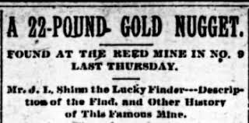
In 1799 an event occurred in the southern Piedmont that made North Carolina a very desirable place to live—the discovery of gold! Twelve-year-old Conrad Reed was fishing in Little Meadow Creek on his family’s farm in Cabarrus County one day in 1799 when he found a seventeen-pound gold nugget. More gold was found in and along the creek, making Conrad’s father, John Reed, a very wealthy man. News of gold in Cabarrus County spread quickly. Soon gold was being found in neighboring counties—Montgomery, Stanly, Mecklenburg, Rowan, and Union—and people anxious to find gold of their own began moving into the area. Charlotte, the state’s largest city today, was merely a dusty little village. Around 1805, only a few years after Conrad’s discovery, newspapers began reporting on gold-mining activities and people coming into the area to search for gold.
There is not much detailed information about those who first came seeking gold. Of course, initially, local landowners did most of the mining. The first newcomers to arrive were probably from neighboring states and somewhat resembled the people already living in western North Carolina. Then, as luck would have it, another event occurred that would greatly increase the numbers, and diversity, of people migrating to the state’s gold fields.
In 1825 Matthias Barringer discovered that gold could be found in veins of white quartz, and by following these veins of quartz into the ground, one could recover more gold. Prior to this discovery, all of the mining conducted in North Carolina had been aboveground. With Barringer’s discovery of “lode,” or underground, mining, the rush to North Carolina was on. People came from far and wide to make their fortunes. Many of the most important lode mines were located in or around Charlotte.

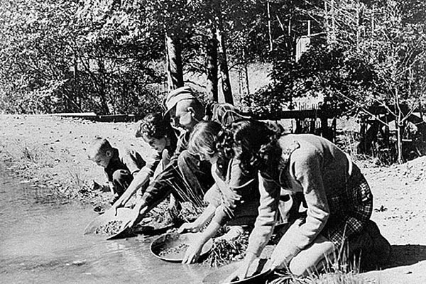
In 1828, the Mecklenburg Gold Mining Company brought in as many as eighty expert miners from England, Germany, Wales, Scotland, Ireland, Switzerland, Italy, and France. Among the European workers, miners from Cornwall, England, had the greatest influence on North Carolina mining culture. They shared their knowledge and expertise in North Carolina. These miners taught proper and safe techniques for lode mining and were also experts in the process of milling gold ore and the use of steam technology. The use of steam engines soon spread from gold mining to other North Carolina industries, such as textile mills. The Cornish miners, were known to be “skilled, superstitious, clannish,” and strongly Methodist. Unlike the single prospectors who followed the gold to California, the Yukon, and beyond, many of these Cornish miners and their families stayed in North Carolina, in the lode mining centers of Charlotte and especially Gold Hill in Rowan County.
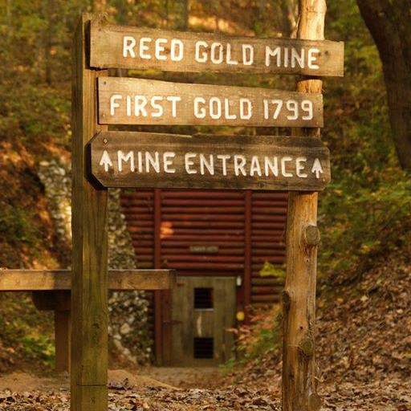
Because the Cornish also spoke English, they and their descendants quickly melded into American life. The influence that they had on North Carolina’s emerging industries, however, is unmistakable. In the early 1800s, North Carolina acquired the nickname “The Rip Van Winkle State,” because so little progress was made that the state appeared to be asleep like that character from literature. The gold industry that the Cornish helped build influenced other developments in industry, commerce, and infrastructure that helped North Carolina lose this reputation. Today’s leaders in industry, research, and banking have indirectly benefited from the foreign miners and investors of the nation’s first gold rush.
- Who first discovered gold in North Carolina? What was he doing? What year?

- What year did people start rushing to North Carolina?

- What is “lode” and who discovered this style?

- What year did Europeans come to Charlotte to join the search for Gold?

- What group of people had the greatest influence on NC mining culture?

- The steam engine, used in gold mining spread to what other industry?

- What brought North Carolina out of its Rip Van Winkle Era?

- What areas of industry still benefit today from the gold rush of North Carolina?

