George Washington

French and Indian War
Washington joined the fight in the French and Indian War in the early 1750s. He signed up with Virginia militia and earned the title as Major. He fought in several battles on the edges of the British frontier. In 1755 he was made commander of all Virginia troops at the age of 23. His soldiers were poorly trained and did not have support of the Virginia colonial legislature. His experience during the war was generally frustrating. He applied for a position within the British army but was turned down.

A month after leaving the army, Washington married Martha Dandridge Custis, a widow who was only a few months older than he. She had considerable fortune and a large estate. He earned 6,000 acres for his military service and became one of the more wealthy landowners in Virginia.

Revolutionary Leadership
After the battles of Lexington and Concord in April of 1775, Washington rode to Philadelphia in his military uniform to visit the Second Continental Congress, indicating he was prepared for war. On June 15 he was appointed Major General and Commander-in-Chief of the colonial forces. He was the best choice to lead the Continental Army for a number of reasons: he had the prestige, military experience and charisma for the job and had been advising Congress for months. He was not necessarily the best qualified to fight against England, however. His training and experience were limited to frontier warfare involving small numbers of soldiers. He wasn’t formally trained in the open-field style of battle practiced by the British generals.

Winning Independence
The British believed that if the major colonial cities were captured, the rebellion would stop. Washington knew that not only were military victories important in winning war, so was keeping the idea of resistance alive within his soldiers and the colonists. The British took control on NY. The French became an ally with the new American nation after Washington’s victory at the Battle of Saratoga in NY. Despite his efforts, Washington never regained control of the state.

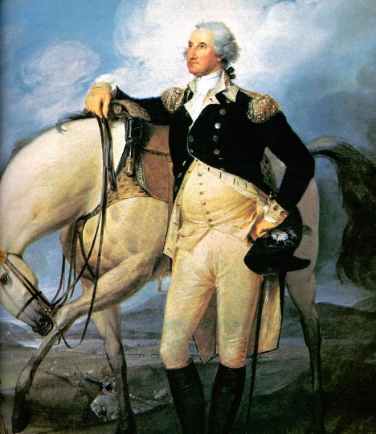
The darkest time for Washington and the Continental Army was during the winter of 1777 at Valley Forge, Pennsylvania. Approximately 11,000 soldiers entered the training camp that winter. Many deserted or left the army and still others died due to a lack of food and supplies.

The British army was ultimately defeated at the Battle of Yorktown in 1781 when the French arrived and aided the Continental Army in cornering British commander Lord Charles Cornwallis.

Washington was very sympathetic to the men who served under him. Although he was stern and commanded the respect his rank in the military deserved, he was also sympathetic to the men who served under him. He wrote many letters to the Continental Congress advising them on military situations and offering suggestions on strategies and decisions. He worked tirelessly to keep his Continental Army intact. He learned from his mistakes and the mistakes of others.

On November 20, 1782, Great Britain acknowledged the independence of the United States, and on September 3, 1783, a treaty of peace was signed at Versailles in France, and America was free.

