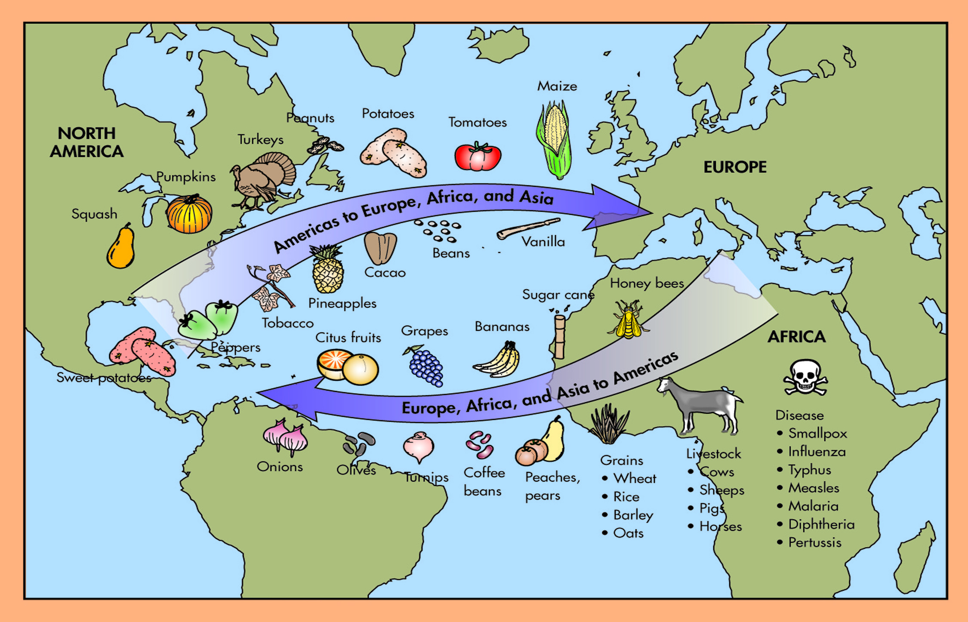
Document #1

As Europeans explored and colonized the New World or the Americas, animals, plants, culture, slaves, technology, and ideas were transferred. This transfer, better known as the Columbian Exchange took place between the 1400s and 1500s. As Christopher Columbus was credited with being the first European to land in the New World in 1492 sparking more exploration, the transfer of goods and ideas was named for him.
_________________________

Document #2

Many things have been said about Columbus in the 500 years since his first voyage. Columbus has received both positive and negative praise for his landing in and the exploration of the Caribbean or Indies.

“The greatest event since the creation of the world (excluding the incarnation and death of Him who created it) is the discovery of the Indies.”  Francisco Lopez de Gomara, 1552  -incarnation: to possess the qualities of a god | “Here was a man greedy in large ways and in small ways--to the point where he took for himself the reward for first sighting land from the Pinto lookout. Cruel in petty things, as when he set a dying monkey with two paws cut off to fight a wild pig; cruel on a continental scale, as when he set in motion what de Las Casas called ‘the beginning of the bloody trail of conquest across the Americas.’”  Hans Koning, 1976
“The discovery of America, and that of a passage to the East Indies by the Cape of Good Hope, are the two greatest and most important events recorded in the history of mankind.”  Adam Smith, 1776 | “He represents the worst of his era. We should honor those who rise above their times.”  Jack Weatherford, 1988
“He might have been an unselfish promoter of geographical science; he proved a rabid seeker for gold and a viceroyalty. He might have won converts to the gold of Christ by the kindness of his spirit; he gained the execrations of the good angels. He might, like Las Casas, have rebuked the fiendishness of his contemporaries; he set them an example of perverted belief.”  Justin Winsor, 1891  -Viceroyalty: colonial land ruled by a representative of the king/queen  -Execration: cursing or detesting  -Rebuked: express sharp criticism | “Columbus is above all the figure with whom the Modern Age--the age by which we may delineate these past five hundred years--properly begins, and in his character as in his exploits we are given an extraordinary insight into the patterns that shaped the age at its start and still for the most part shape it today.”  Kirkpatrick Sale, 1991  -delineate: to trace  -exploits: heroic act
“He had his faults and defects, but they were largely the defects of the qualities that made him great--his indomitable will, his superb faith in God and in his own mission as the Christ-bearer to lands beyond the seas, his stubborn persistence despite neglect, poverty, and discouragement. But there was no flaw, no dark side to the most outstanding and essential of all his qualities--his seamanship.”  Samuel Eliot Morison, 1942 | “What are [the] positive aspects of the Columbus legacy? If you’re talking about the horse, yeah, we like the horse. Indians raised the use of the horse to a high military art. Was that a good result of that invasion? Yes. Is it something we would have traded for the many Indian peoples who are no longer here because of that invasion? No.”  Suzan Shown Harjo, 1991

Document #3

On February 15, 1493, Christopher Columbus wrote a condensed account of his first voyage which was published all over Europe. The excerpts below tell of his first impressions of the new land.

Sir...There I found very many island, filled with innumerable people, and i have taken possession of them all for their Highnesses, done by proclamation and with the royal standard unfurled, and no opposition was offered to me…

The people of this island and of all the other islands which I have found and of which I have information, all go naked, men and women, as their mothers bore them…. They refuse noting that they possess, if it be asked of them...I give them a thousand handsome things...in order that they might conceive affection for us and, more than that, might become Christians and be included to the love and service of Your Highnesses….

I have taken possession of al for their Highnesses, and all are more richly endowed than I know how or am able to say, and I hold all for their Highnesses, so that they may dispose of them as they do…. Bu especially in Espanola, in the situation most convenient and in the best position for the mines of gold and for all trade and profit…

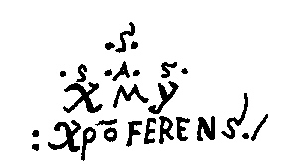
Since Our Redeemer has given the victory to our most illustrious King and Queen, ...for this all Christendom ought to feel delight and make great feasts and give solemn thanks to the Holy Trinity, with many solemn prayers for the great exaltation which they shall have in the turning of so many peoples to our holy faith, and afterwards for the temporal benefits, because not only Spain but all Christendom will have hence refreshment and gain.

(Christopher Columbus’ secret signature)

