Name: ______________________ Date: __________________ Block: _______
Unit 1 State of Inquiry: Beliefs, values, and relationships influence people’s behavior and affect the formation of culture and identity.
IB Learner Profile of focus for this assignment: Communicator

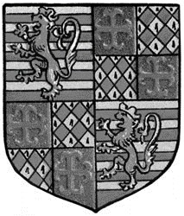
Personal Identity Coat of Arms:
During the Middle Ages, individuals were identified by their Coat of Arms. Since they were used on the battlefield to identify a person’s friends and foes, they were often in the shape of a shield. The symbols used on coats of arms were chosen carefully to represent an individual or an entire family. The Coat of Arms described their personal identity
------------------------------------------------------------

Design Your Own Coat of Arms to describe your personal Identity
For this assignment, you will be creating your own personal coat of arms based on your hobbies, personality, goals, and family. Essentially, you job is to show us who you are and describe your personal Identity. You have been provided with a shield that is divided into four segments. The directions below tell you what to include in each segment.
Once you have created your coat of arms, you will write a few paragraphs explaining the key points of your design and why you chose to create it like this.
----------------------------------------------------------------------------------------------
Directions Make sure your personal identity shield is neat and in color. This assignment will be graded on your effort not your artistic ability, so try your best. You will have the opportunity to share your coat of arms if you choose.
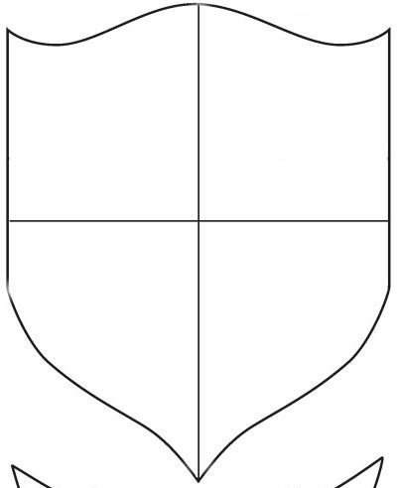
Section 1 (Upper Left): In this section, you will draw something that represents your personality and at least one personal interest. For example, you may want to consider drawing something that represents one of your hobbies.
1
.
2
.
3
.
4
.
Section 2 (Upper Right): ): In this section, you will draw something that represents your family. Keep in mind, that family is however you define it.
Section 3 (Lower Left): In this section, you will draw something that represents one of your goals. This could be a long term goal, such as something you want to accomplish when you grow up, or it could be a short term goal, such as something you want to accomplish this school year.
Section 4 (Lower Right): Create a personal Motto or Slogan that represents your beliefs or values.
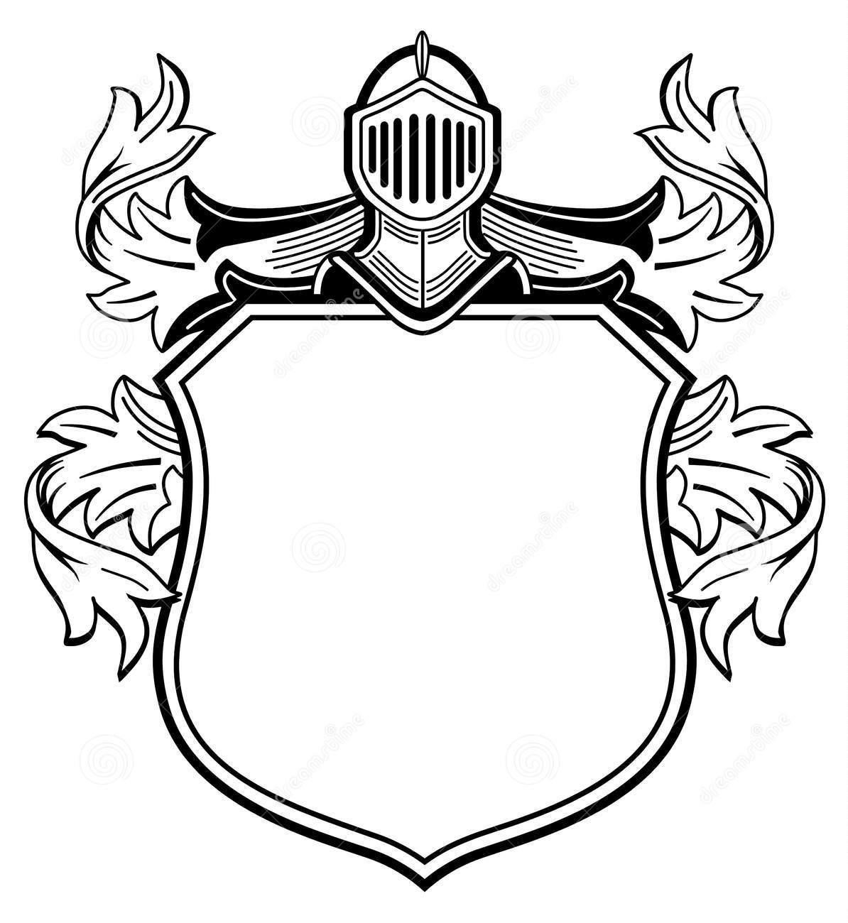
Name: __________________________________________________________ Date: __________________
Personal Coat of Arms Description
Directions: On this page, you will describe EACH section of your coat of arms. Explain what you
drew and why you chose that design. This needs to be printed in paragraph format. Don’t forget to use proper grammar!
__________________________________________________________
__________________________________________________________
__________________________________________________________
__________________________________________________________ __________________________________________________________ __________________________________________________________
__________________________________________________________
__________________________________________________________ __________________________________________________________ __________________________________________________________
__________________________________________________________
__________________________________________________________ __________________________________________________________ __________________________________________________________
__________________________________________________________
__________________________________________________________ __________________________________________________________ __________________________________________________________

