Name: _________________________ Date: ___________ Block: _________
Unit 2 IB GRASP writing assessment.
DUE DATE: Friday, January 11th
IB statement of inquiry for this unit:
“Conflict often arises between cultures due to their varying perspectives, philosophies, and ways of life.”
Directions:
You will create an original letter as a primary source. In your original work, you will want to use vocabulary relevant to the time period consistently throughout your work. Be sure to include historically and geographically accurate details, plenty of examples and fully developed ideas. There should be historical references consistently throughout the work. It should be well organized, with a clear beginning, and end, and should be chronologically accurate
G (goal): Your assignment is to write a letter home from the battlefront. You will be a soldier from the Civil War. Include specific information about the war. You may use your notes, the readings, or do your own research to include accurate information.

R (role): you will assume the role of a Union soldier and a Confederate soldier from two different battles in the Civil War.

A (audience): Someone back home. Mother, Father, husband, Wife, sibling, friend, etc.

S (situation): Your situation is to describe your life on the battlefield. Were you in the Union or Confederacy? Why are you fighting? What battle where you a part of? Who were you fighting against? What are your concerns? Etc.

P (product): Your product is as follows:
- Two letters written from the perspective of a soldier. (one from the Union and one from the Confederacy)
- After reading the letter, it is clear to whom the writer is writing.
- The writer explained what they have done during the war, what they are doing and what they are planning to do after writing the letter.
- At least five facts discussed in class or from an assignment were used in the letter.

**You MUST choose TWO DIFFERENT BATTLES. i.e. if your Union Soldier participated in the battle of Gettysburg, then your Confederate soldier must participate in a different battle.** Circle your choices in each category.

Union Soldier | Confederate Soldier
First battle of Bull Run | First battle of Bull Run
Battle of Shiloh | Battle of Shiloh
Battle of Antietam | Battle of Antietam
Battle of Gettysburg | Battle of Gettysburg

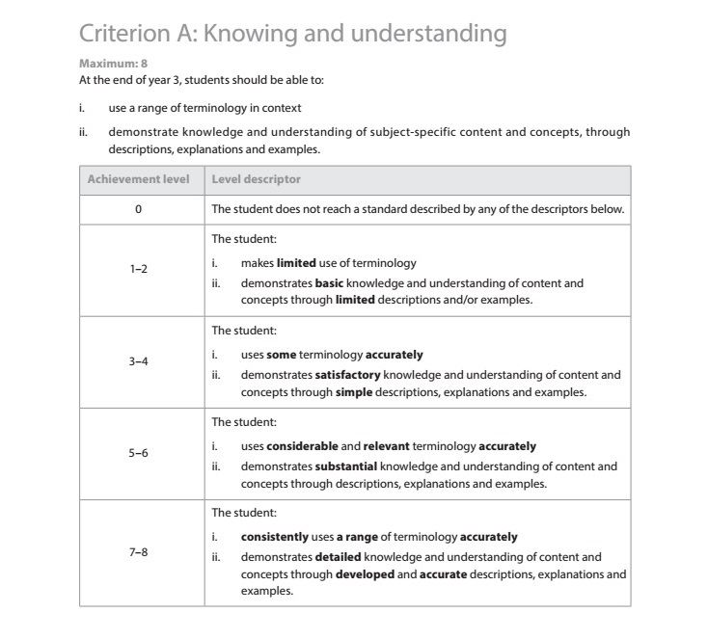
**Your original work will be evaluated based on the IB assessment criterion A and C rubric.*
