Name: Date: Block:

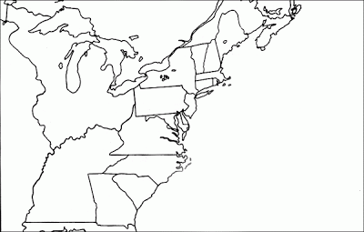
The 13 English Colonies:
Key:
SOUTHERN COLONIES =
MIDDLE COLONIES =
NEW ENGLAND COLONIES =

Directions:
- Locate and label the original thirteen colonies.
- Color the colonies and Key according to which region they are a part of (Southern, Middle, or New England)
- Label and Color the Ocean Blue
- Color the land that is not part of the thirteen colonies brown

Founding of the Thirteen Colonies.

Colony Name | Date Founded | Reasons for founding | Leader/founder
New England Colonies
Massachusetts
New. Hampshire
Rhode Island
Connecticut
Middle Colonies
New York
Pennsylvania
New Jersey
Delaware
Southern Colonies
Maryland
Virginia
North Carolina
South Carolina
Georgia

