Name: Date: Block:

Imperialism and Nationalism Terminology

Directions: Using the definitions from your notes or my powerpoint write the definition for each term IN YOUR OWN WORDS, then write a sentence using the word in it. If you just copy down my definitions, you will not get full credit!
Term | Definition  IN YOUR OWN WORDS | Sentence
Imperialism
White Man’s Burden
Berlin Conference
Sovereignty
Social Darwinism
Capitalism
Nationalism
Militarism
Propaganda
Fascism

Answer the following questions in the space provided.

- How does a country’s Nationalism, fuel Imperialism?

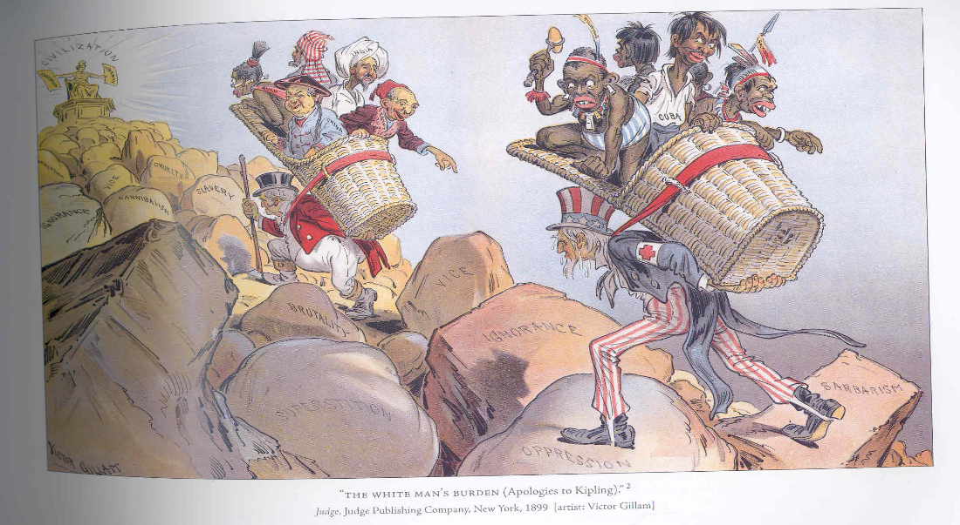

Based on the picture above, what message is the artist trying to convey regarding the idea of “The White Man’s Burden”?

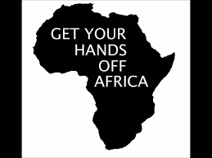

What group of people may have created this propaganda poster? And WHY?

