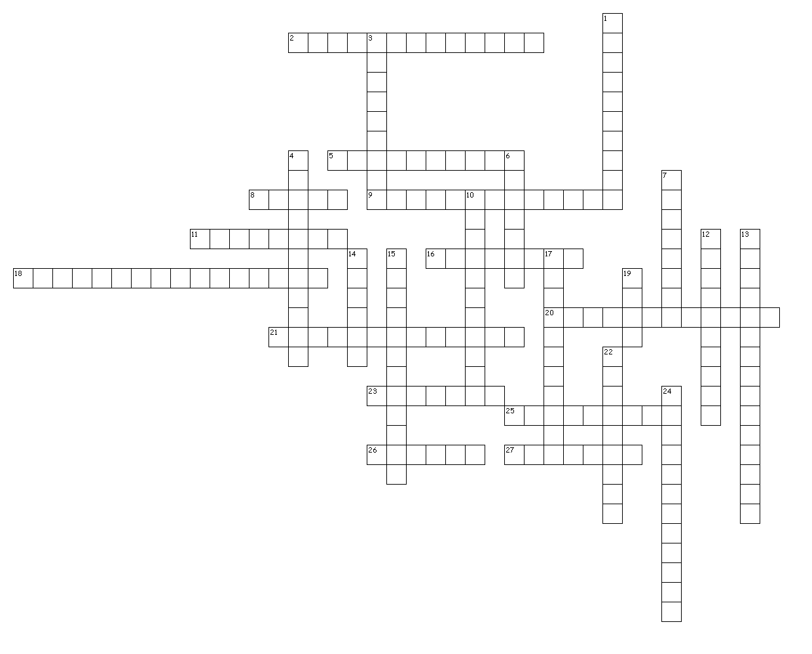
Name:

Date:

Block:

Across
2. This invention was critical to the success of Martin Luther and the Protestant Reformation.

5. another word for "lightning war"

8. Italy, Germany, and ______ made up the Axis powers in WWII

9. the Enlightenment influenced revolutions because it ideas were all about people's _________ __________

11. Britain and France wanted Germany to permanently reduce this after WWI.

16. Major characteristic of the Renaissance.

18. This was a major reason for European countries imperialization of Africa

20. The scientific revolution is considered an ______________ Revolution.

21. This organization formed at the end of WWII

23. This is another word for totalitarianism

25. Trench Warfare created a massive __________.

26. Britain and France declared war on Germany in WWII after Germany invaded this country.

27. WWI trench warfare was fought on which front?

Down
1. The treaty of _________ ended WWI.

3. Both the reformation and Renaissance are similar in that they encouraged people to question _________.

4. This was the policy that Britain and France took with Germany and Hitler after he invaded Czechoslovakia

6. The treaty of Versailles which ended WWI put harsh punishments on what country?

7. partnership between Germany, Austria-Hungary, and Italy during WWI. The Triple _________.

10. The United States dropped two of these on Japan and ended WWII

12. Policy of having a large standing army ready for war.

13. belief that stronger countries should take over weaker ones.

14. Believed that people needed harsh and strict laws

15. people moving from farms to the city

17. This is how people were divided in France before the Revolution.

19. God, Glory and _______ are known as "The 3 G's"

22. Note sent to Mexico from Germany to ask for help in WWI

24. Sun is the center of the Universe.

